**PYTHON LABORATORY**

**Exercise No:10**

**Date:22/11/2020**

**Aim:**

Write a Python function that accepts a string and calculate the number of upper case letters and lower case letters.

**Program:**

def string(s):

d={"UPPER_CASE":0,"LOWER_CASE":0}

for c in s:

if c.isupper():

d["UPPER_CASE"]+=1

elif c.islower():

d["LOWER_CASE"]+=1

else:

pass

print("No. of Upper case characters:",d["UPPER_CASE"])

print("No. of Lower case characters:",d["LOWER_CASE"])

s=input()

string(s)

**Output:**

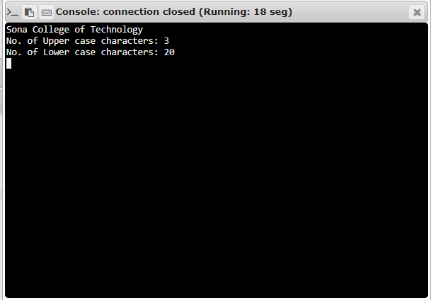

**Link:**

[**http://103.53.53.18/mod/vpl/forms/edit.php?id=325&userid=1708#**](http://103.53.53.18/mod/vpl/forms/edit.php?id=325&userid=1708)

**RESULT:**

The number of uppercase and lowercase is calculated and displayed successfully.